Framework agenda for meetings and study visits within the CRinMA project
on September 11th -14th , 2017

STUDY VISIT
“ALTA LANGA MOUNTAIN AREA”

DAY 1 September 11th 2017,
Travel day from Torino main Station Porta Nuova

Transfer from Turin main station Porta Nuova to Cortemilia (CN)
Free Bus will be organized at 20.00

Arrival to Cortemilia to the hotels and rural tourism accommodation.

DAY 2 September 12th 2017, Cortemilia

09.00 - 09.30 Registration of participants and coffee “Eco Museum of dry stone and terraces” Monte Oliveto

Welcome of the Mayor

09.15 13.00 Partner meeting

Financial Report and questions

Activity Report and further actions

13.00 - 14.00 Lunch organized at Monte Oliveto in collaboration with the Municipality

  - Departure for the study trip by bus

Alta Langa Tour
Artistic Village of Bergolo restored in stone
Medioeval Castle of Prunetto
Agro Farm „Cascina Crocetta” Castelletto Uzzone

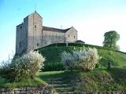

Dinner in Prunetto „Ristorante della Piazza”
21.00 Return to Cortemilia

DAY 3, September 13th, 2017, Alta Langa Tour
Touching Heritage - Study Visit

08.00 Departure

- Cheese makers Murazzano in Paroldo village
- Visit of the „Spread Hotel” of Paroldo

- 12.30 – 13.30 Lunch at Agrofarm of President of Murazzano Consortium http://www.cascinaraflazz.it

14.00 Transfer to

- Murazzano village and Consotium of Murazzano cheese Dop

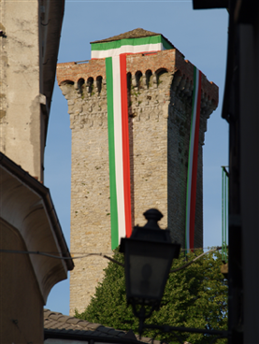

- Bossolasco Village
http://www.bossolascolanghe.it/eng/centrostorico.htmle and Castle
Meeting with Leader programme Director Ms. Giusi Casucci
- Albaretto Tower
17.00 Return to Cortemilia

17.30 REGIONAL CONFERENCE – in Cortemilia – Convento di San Francesco

-Opening - Roberto Bodrito - Mayor of Cortemilia
Project Presentation – Katarzina Opoczka – Malopolska Region Project Leader

Invited speakers:
Alberto Cirio – MEP and President of GAL Langhe Roero
Alberto Valmaggia Regional Ministry to Mountain Policies
Regional Manager - Alcotra

Conclusions
Lido Riba – President UNCEM

20.30 Aperitif with folk music entertainment

21.00 Dinner in „Castel Martino” - Cortemilia

DAY 3, September 14, 2017, Travel Day
Trasfer to Torino and Main Station Porta Nuova

08.30 Departure from CortemiIia

10.30 Visit to the National Mountain Museum in Torino
http://www.museomontagna.org/it/home/index.php

13.00 Departure to Torino Porta Nuova Station

