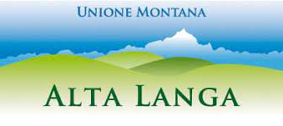
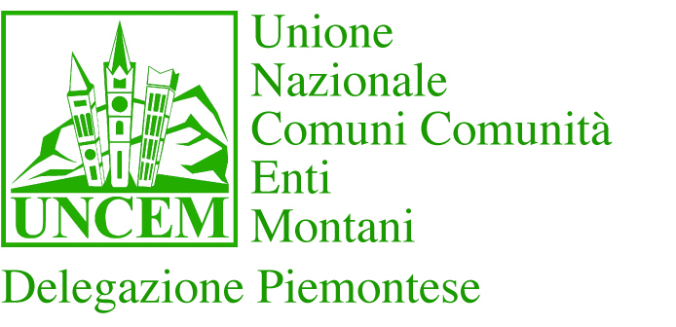
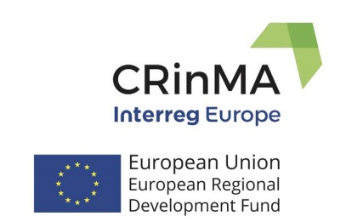

TRANSNATIONAL TRAINING WORKSHOP
Unione Montana Alta Langa
Piazza Oberto, 1
BOSSOLASCO

08/11 April 2019

PROGRAM

8th April 2019: TRAVEL DAY
Transfer from Turin airport to Bossolasco by bus at 19.00/19.30 and accommodation in Bossolasco Hotels.

9th April 2019: TRANSNATIONAL WORKSHOP DAY (Unione Montana Alta Langa Piazza Oberto, 1 Bossolasco)

09:30 - 10:00 Registration for the Transnational Workshop
10:00 - 10:15 Welcome speeches Mr. Franco Grosso Mayor of Bossolasco –Mr. Roberto Bodrito President Alta Langa- Lido Riba President UNCEM Piemonte – Marco Bussone President National UNCEM

Transnational workshop Part 1 – Cultural Heritage in Langa - Dry Stone – UNESCO Heritage – Competences, skills and traditions.

10.15 – 10.30 “Not only food but Cultural Heritage as attraction of Langhe”
Mr. Mauro Carbone Director Tourist Agency Langhe Roero http://www.langheroero.it/

10.30 – 10.45 “GAL Langhe Roero. Initiatives and projects to support Cultural Heritage”
Ms. Giusi Casucci Director GAL https://www.langheroeroleader.it/

10:45 – 11.00 Coffee-break

11:45 – 12:00 “Dry Stone – the roots of Alta Langa Culture” Father Toio del Piano

13:00 – 14:30 Lunch

Transnational workshop Part 2 Dry Stone experience in San Benedetto Belbo and Monbarcaro
Transfer by bus

14:30 – 16:30 Dry Stone experience in San Benedetto Belbo

16:30 – 19:00 Innovation and Culture - Restoration Church in Mombarcaro and visit to hazelnut factory

19:00 – 21:00 Dinner in Bossolasco.

10th April 2019: Steering Committee Meeting and Training in Bossolasco and Grinzane

09:30 – 12.30 Steering Committee Meeting in Unione Montana Offices.

13:00 – 14:00 Lunch

15:00 – 18.30 Best practice in Museums Regeneration Transfer by bus to “Castello di Grinzane Cavour” www.castellogrinzane.com

19:00 – Dinner

11th April 2019: TRAVEL DAY

Transfer from Bossolasco to Turin Airport by bus at 7.30/8.00.

